

This is an outgoing email ONLY OCTOBER-DECEMBER 2019 NEWSLETTER

P.O. BOX 3027

3802 HIGHWAY 11S

RICEVILLE TN 37370

PHONE: 423-462-2701

FAX: 423-462-2830

RICEVILLE UTILITY DISTRICT



REMINDERS

* Keep all meters accessible for easy, accurate reading.
* Monthly meetings- 3rd Thursday at the office.
* Keep us informed with updated addresses and phone numbers for emergencies.

HOURS:

MON-FRI 8AM-4PM

PAYMENT METHOD:

CASH/CHECK/CREDIT CARD AT OFFICE-Drive-Thru/Night Drop

SOUTHEAST BANK AND TRUST(B-4 15th)

AUTO DRAFT(Drafted 7th)

WWW.RICEVILLEUTILITYDISTRICT.ORG

METERS ARE READ BETWEEN 8TH AND THE 20TH OF EACH MONTH.

BILLS WILL BE MAILED TO CUSTOMERS BY THE LAST DAY OF EACH MONTH.

BILLS CAN BE PAID WITHOUT PENALTY UNTIL THE 15TH OF EACH MONTH, AFTER THE 15TH A 10% PENALTY WILL BE ADDED TO THE BILL.

ACCOUNTS OVER $70 NOT PAID BEFORE THE 22ND OF EACH MONTH WILL BE SUBJECT TO BE DISCONTINUED (CUT OFF) AND A FEE OF $50 (AFTER HOURS $100) WILL BE CHARGED FOR RECONNECTION.

COMMISSIONERS:

* RICK BROWN
* RON BANKS
* JEFF MELTON

HEAT!! And its effects……

The rain a few months ago caused finding leaks a near impossible task but now we have been faced with a new challenge. The heat is drying out the ground making it a hard surface for pipes. Tree roots are looking for water and finding water lines as a source of supplement. Our field team has been working nonstop on locating and repairing these leaks.

Our new equipment has been a large cost saver during this time in lower water loss, fewer water outages, and less repair bills.

RUD thanks our customers in their diligence in reporting issues in a timely manner. This quick response has prevented larger leaks and possible water outages.

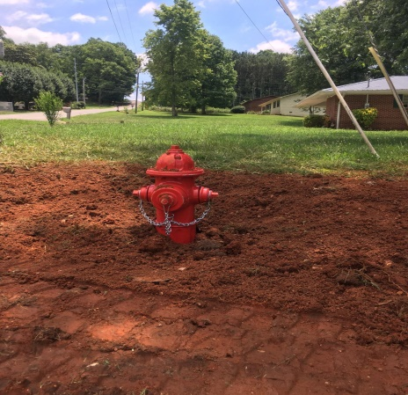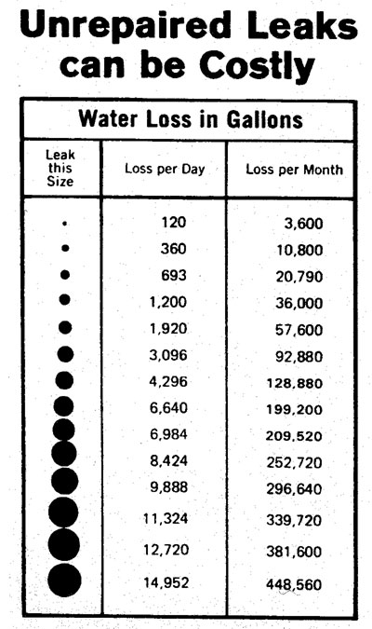

NEW….

Riceville Fire Department requested a new fire hydrant for County Road 709 and Hwy 39 Intersection. McMinn County approved and helped fund this installation.

RUD as of June 2019 has installed and added this hydrant to our water system.

Customers within a 1 mile radius of this hydrant need to contact their home insurance providers and add this to their coverage for a discount.

If you would like to unsubscribe to these newsletters please call the office at (423)462-2701.

Water Rates (as of 8/1/19)

Residential-Minimum Bill $25.97(+Tax) 2000 Gallons

Over 2000 Gallons $.52 Per 100 Gallons

Commercial-Multi Use-

Minimum Bill

$33.29 (+Tax) 2000 Gallons

Over 2000 Gallons $.93 Per 100 Gallons